**Dichotomous Key to identify properties of Igneous Rocks**

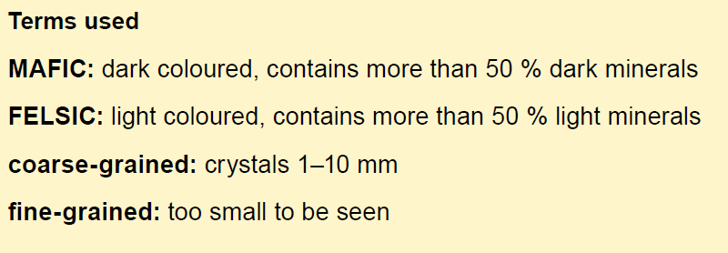

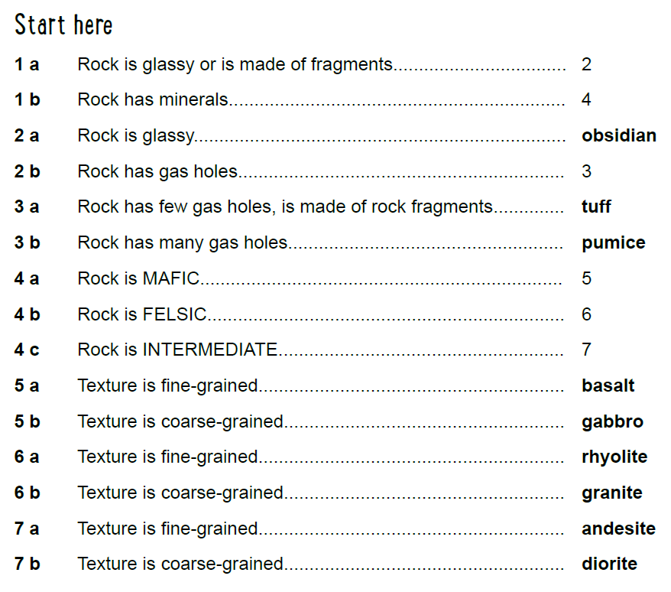

|  |  |
| --- | --- |
| Rock 1: _______________________  C:\Users\sjare4\AppData\Local\Microsoft\Windows\INetCache\Content.MSO\27A0B242.tmp | Rock 2: ________________________  C:\Users\sjare4\AppData\Local\Microsoft\Windows\INetCache\Content.MSO\D5AECBA0.tmp |
| Rock 3: _______________________  C:\Users\sjare4\AppData\Local\Microsoft\Windows\INetCache\Content.MSO\CCAB52AE.tmp | Rock 4: ________________________  C:\Users\sjare4\AppData\Local\Microsoft\Windows\INetCache\Content.MSO\66F982EC.tmp |